California State Polytechnic University, Pomona

Lab 7: BCD Up-Down Counter

Group F:

Danny Manzo, Bronco ID: 014451190

Maher Mateen, Bronco ID: 013891189

ECE 3101L – Signals and Systems Laboratory

Professor Mohamed Aly

8 August 2022

1. **How a BCD Counter Works:**

A Binary Coded Decimal (BCD) counter is a digital counter that is designed by a group of flip-flops with an applied clock signal that resets for every new clock input. The BCD counter is a 4-bit binary digital counter that counts from 0 to 9 with an applied clock signal. Depending on the input we give it, the BCD counter can count upwards or it can also count downwards. As it counts upward, the 4-bit binary input starts at 0000 while as it counts downward, the binary input starts at 1001.

1. **How We Coded It:**

To code the BCD Up Down Counter, first we made a clock divider that has a default period of 2 s (slowest speed), and increases up to a 31.25 ms period (fastest speed), depending on a 5 bit switch input that affects the clock speed. Next, we created a stacked counter that consists of 8 different counters for the 8 7-segment displays. In these counters, we load a 4-bit input through a 4-bit switch input that goes into a 1x8 Demux with a 3-bit select input. This 1x8 Demux outputs an 8-bit long wire that only has 1 bit high at a time(i.g. 8’b00000001 or 8’b00001000), that is used as an input to the stacked counter to select which counter gets the 4-bit input loaded into it. We used a generate for loop to create the stacked counter by having an enable out coming out from the previous counter that becomes the enable in of the next counter. Lastly, we used the code for the 7-segment display truth table, the digit selector for the 7-segment displays, and the 7-segment display selector from previous labs to output the 32 bit stacked counter.

1. **Vivado Data Collection:**

In Vivado, after running the synthesis and report utilization, we found that there was 191 look-up tables (LUTs), 141 slice registers, 4 F7 Muxes, 70 slices, 191 LUTs as logic, 84 LUT Flip Flop Pairs, 33 bonded input/output bits (IOB), and 2 BUFGCTRL. The total power of the Up-Down BCD Counter was reported to be 0.105 W.

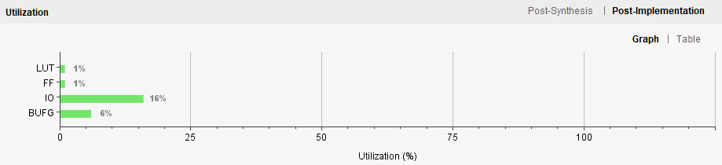

Figure 1: Resource Utilization Graph

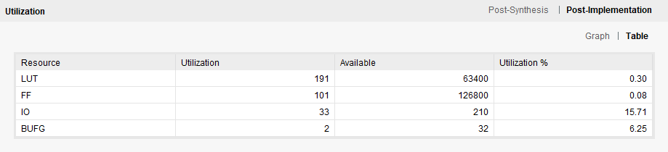

Figure 2: Resource Utilization Table 1

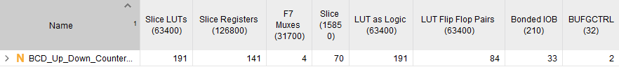

Figure 3: Resource Utilization Table 2

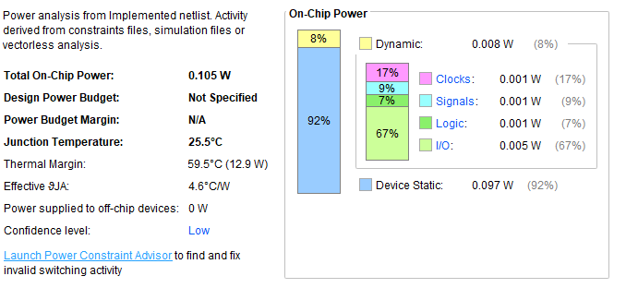

Figure 4: Power Usage